+

|  |  |  |  |
| --- | --- | --- | --- |
| **Story Title:** | SAMAST_STOA NOC_02: Apply for NOC for Exchange Trade and Concurrence for Bilateral Trade. | | |
| **Module Name:** | Open access Module | **Created By:** | Abhijeet Kumar |
| **Created Date:** | 20/07/2022 | **Version:** | 1.1 |
| **Approved By:** |  |  |  |
| **As a Business Analyst** | **I want to** | **so that** | |
| End User | Make OA NOC/Concurrence Apply screen | The Buyer/Seller can apply for NOC/Concurence. | |
| **Definition of Done** | The User shall be able to apply for NOC/concurrence. | | |

## Approval from Associated Stakeholder

|  |  |  |  |
| --- | --- | --- | --- |
| **Dilip Makwe**  **(Principal Technology Officer)** |  | **Amit Yadav (Technical Lead)** |  |
| **Vipul Srivastava (Delivery Manager)** |  | **Suresh Kumar**  **(Asst. Vice President)** |  |

**Business Requirement**: In the OA view dashboard, the buyer/seller should be able to apply for NOC for Exchange Trade and Concurrence for bilateral trade.

## In scope:

## NOC screen to apply for Exchange Trade

## Concurrence screen to apply for Bilateral Trade.

SAMAST

DB

**Description**

Once a Grant (Final Approval) has been provided to a Buyer/ Seller, then they can apply for fresh NOC/ Concurrence i.e. purchase/ sale through Exchange or Bilateral respectively from “Buyer/Seller OA grant and NOC/Concurrence Dashboard”

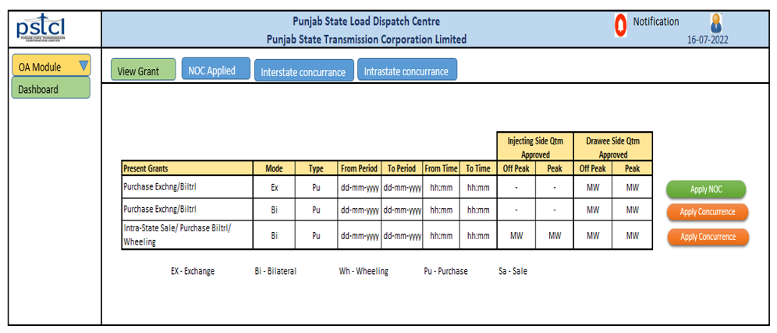

**Fig 1: Buyer/Seller OA grant and NOC/Concurrence Dashboard**

### **1. Apply for NOC for Exchange Trade**

When in the **“Buyer & Sellers’ NOC/Concurrence Dashboard”** screen the applicant clicks on the “Apply NOC” button in against of a Grant, then the following form should open and user needs to fill in the details and upload the necessary details:



**Fig 2: NOC Form to Apply for Exchange Trade**

**`1.1 Following Buttons that we need to integrate in the NOC form:**

1. **Cancel**: This will cancel or close the form.
2. **Download form to Sign & Mail**: This will download the form filled by the user for the user to sign the document. This authorized signatory part will be downloaded along with the filled document. The below mentioned portion will get attached to the form for signing and company seal:



1. **Submit:** This will help the user to Submit the filled form along with documents to upload.
   1. **The following criteria should be followed to fill the form:**



**1.3 Business Rule:**

* The Period for application should not be more than 31 days.
* Minimum 3 and Maximum 15 working days in Advance this form should be submitted by Applicant to get the NOC.
* The first NOC after a Final Approval should be free, so the Application fees section in the form should be freezed for first application only.

1. **Apply for Concurrence of Bilateral Trade**

When in the **“Buyer & Sellers’ NOC/Concurrence Dashboard”** screen the applicant clicks on the **“Apply Concurrence”** button in against of a Grant, then the following form should open and user needs to fill in the details and upload the necessary details:

* 1. **Apply for Concurrence of Bilateral Trade**



**Fig 3: Concurrence Form to apply for Bilateral Trade**

**2.2 Following Buttons that we need to integrate in the Concurrence Form**

* **Cancel**: This will cancel or close the form.
* **Download form to Sign**: this will download the form filled by the user for the user to sign the document. When downloaded along with the filled document the below mentioned portion will get attached to the form for signing and company seal:



* **Check Charges Amount**: By this an excel file will get downloaded and user will fill necessary details to get the calculation of Charges, so that they can pay the amount and apply for Concurrence.
* **Submit**: This will help the user to Submit the filled form along with documents to upload.
  1. **The following characteristics that need to be considerd while filling the Concurrence form:**



* 1. **Business Rule:**
* The Period for application should not be more than 31 days.
  + 1. **Bilateral transactions (Involving inter-State transmission system/ Inter State Transactions):**
  + **Advance** – ­
    - Transaction for 3 months max is allowed
    - Individual punch in RLDC for different month is required
    - Suppose power is required from 01-08-2021 to 31-10-2021, and today is 17-07-2021
      * for August's power punching is to be done 10 days prior to current month's last date, i.e. by 21-07-2021.
      * for September's power punching is to be done 5 days prior to current month's last date, i.e. by 26-07-2021.
      * for October's power punching is to be done on last day of current month's, i.e. by 31-07-2021.
  + **FCFS (First Come First Serve)**
    - The Transaction should start and end in same month
    - Punching should be done 4 days before the 1st delivery day
  + **Day Ahead**: Application should be punched in RLDC before the preceeding day of the Delivery date by 15:00 hrs.
  + **Contingency/ Intra Day**: Application punched after 15:00 hrs is treated as Contingency.

**2.4.2 Bilateral transactions (Without involving inter-State transmission system/ Intra State Transactions):**

* + **Advance:**
    - Individual punch in SLDC for different month is required
    - Application is to be submitted by 15th of a month preceding the month of delivery
  + **FCFS (First Come First Serve):**
    - The Transaction should start and end in same month
    - Punching should be done 4 days before (by 1700 hrs) the 1st delivery day
  + **Day Ahead:** Application should be submitted in SLDC from 3 days before till 1500 hrs of the preceeding day from the date of Delivery.
  + **Contingency/ Intra Day:** Not there in Intra State transaction.
    1. **Conditions:**

1. The first Concurrence after a Final Approval should be free, so the Application fees section in the form should be freezed for first application only.
2. When Applicant applies for NOC/Concurrence, then system will generate an application No. in against of the same:

Application No. for NOC: PE_NOC_XXXX

Application No. for NOC: PB_CON_XXXX

**Note:** Where PE is Power from Exchange, PB is Power from Bilateral, NOC is No Objection Certificate and CON is for Concurrence.

1. **NOC/Concurrence View Screen for Sellers/Buyers**

